EC2 Reverse Proxy NGINX Deployment with Terraform
A fully automated AWS infrastructure deployment using Terraform, featuring a custom VPC, public/private subnets, routing, security groups, and an EC2 instance running NGINX.

1. Project Overview
Today, we’re building an automated AWS EC2 deployment where NGINX acts as a reverse proxy using Terraform, meaning we’ll provision the infrastructure, install and configure NGINX, and route incoming traffic to backend services—all through code for a repeatable, production-style setup.
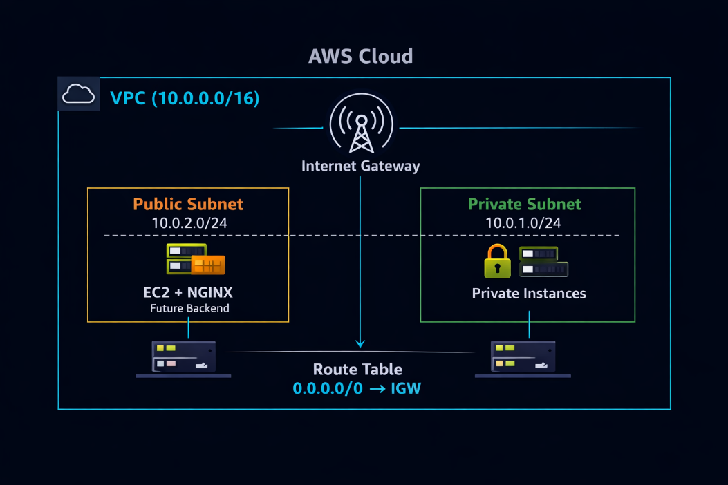
AWS network and compute environment using Terraform. It includes:
- A custom VPC (10.0.0.0/16)
- Public and private subnets
- Internet Gateway + Route Table
- EC2 instance running NGINX as a reverse proxy
- Security groups enforcing least-privilege access
- Fully automated provisioning using Terraform AWS provider v4.67
This project demonstrates cloud infrastructure automation, network design, and secure provisioning using Infrastructure-as-Code.

2. Architecture Summary
In this step, I will create the VPC & Networking because this step lays the network foundation for our entire architecture, ensuring that our infrastructure is secure, properly segmented, and internet-accessible where needed.

The public subnet allows the NGINX reverse proxy to receive traffic from the internet via the Internet Gateway, while the private subnet keeps backend resources isolated and protected from direct exposure. This separation follows AWS best practices by exposing only necessary components and limiting the attack surface, while route tables control traffic flow—using 0.0.0.0/0 to direct internet-bound traffic through the Internet Gateway for public access.

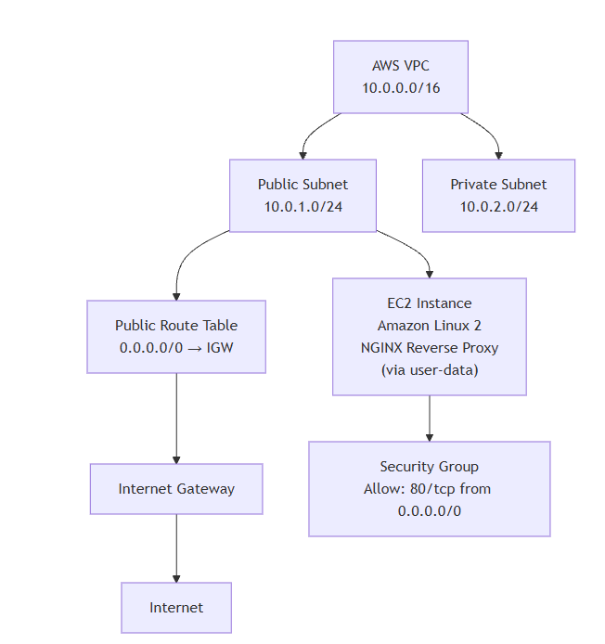
The deployment creates the following components:
VPC & Networking
- Custom VPC: 10.0.0.0/16
- Public subnet: 10.0.2.0/24 (auto-assign public IP)
- Private subnet: 10.0.1.0/24
- Internet Gateway for outbound traffic
- Route table with default route 0.0.0.0/0 → IGW
- Route table association for the public subnet
We need a public subnet, private subnet, route table, custom VPC, and Internet Gateway to build a secure and functional architecture. The custom VPC gives full control over networking and security, while the public subnet (with auto public IP) allows internet-facing resources like the NGINX reverse proxy to be accessible. The private subnet keeps backend services isolated from direct internet exposure for security.
The Internet Gateway (IGW) enables communication between the VPC and the internet, and the route table with 0.0.0.0/0 → IGW, associated with the public subnet, ensures external traffic can reach only the public resources. Together, this setup creates a controlled flow where users access the proxy publicly, while backend systems remain protected
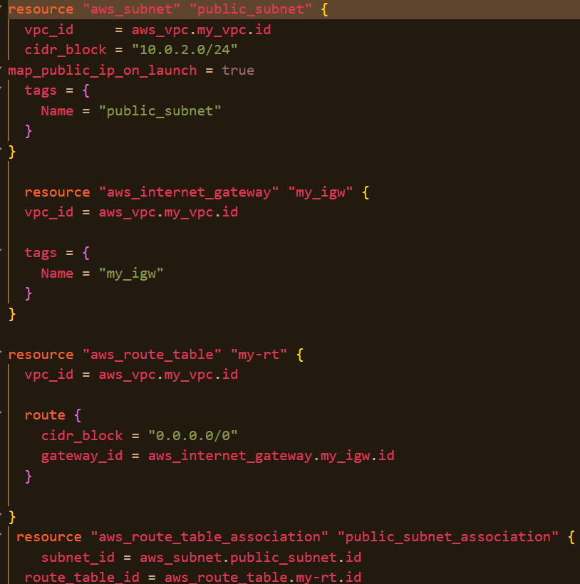
In this step, we will launch the compute layer (EC2 instance) to host our application, using user data to automatically configure the server by installing and starting NGINX as soon as the instance boots.

This is important because it allows us to automate server setup, ensuring the instance is ready to handle traffic immediately without manual intervention. Instead of logging in and configuring the server each time, user data runs scripts at launch to perform tasks like software installation and service configuration, making the deployment faster, consistent, and scalable across multiple instances

Compute Layer
- EC2 instance type: t3.nano
- AMI: Amazon Linux 2 (ami-08281fe2ffa674f)
- User data installs and starts NGINX
- Public IP assigned automatically

Security
In this step, we set up a security group to control traffic to our EC2 instance. The ingress rule allows incoming HTTP traffic on port 80, so users can access the NGINX web server, while the egress rule allows outgoing traffic to any destination, enabling the instance to communicate externally (e.g., install updates or fetch packages)
- Security group allowing inbound HTTP (80)
- Outbound traffic fully open (default)
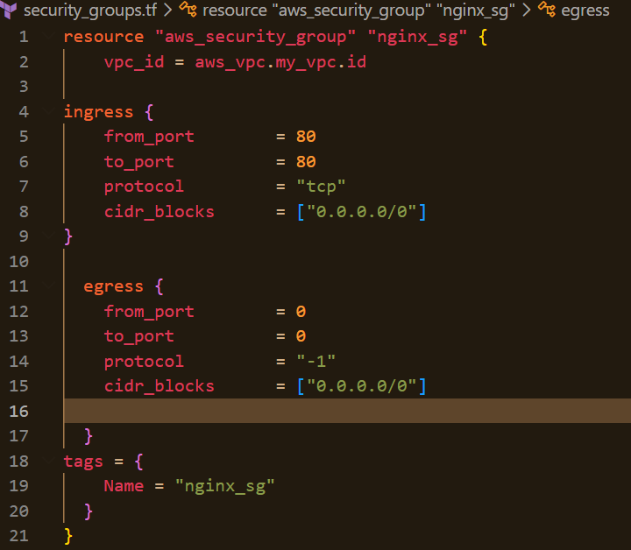

3. Terraform Implementation
For this project, Terraform is the tool we use to build and automate our cloud infrastructure using code, instead of manually creating resources in AWS. It allows us to define components like the VPC, subnets, route tables, and EC2 instances in a repeatable and consistent way.
The main.tf file is the primary configuration file where we define all the infrastructure we want to create—such as the custom VPC, public and private subnets, Internet Gateway, route tables, and the EC2 instance running NGINX.
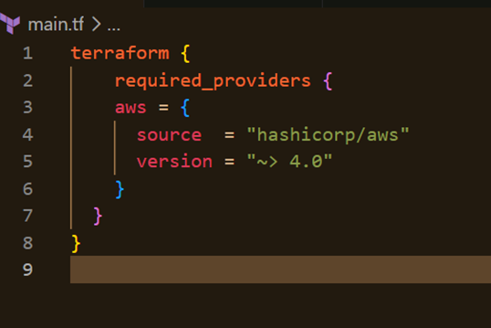

It acts as the main entry point of our Terraform project, bringing together all resource definitions into one place so Terraform can provision everything automatically.
The project is split into modular files:
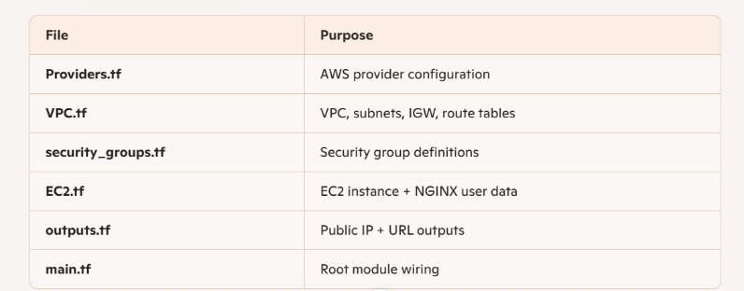

Technologies Used
- Terraform (AWS provider v4.67)
- AWS EC2
- AWS VPC
- NGINX
- Amazon Linux 2

📜 EC2 User Data (NGINX Install Script)
bash
#!/bin/bash
yum update -y
amazon-linux-extras install nginx1 -y
systemctl enable nginx
systemctl start nginx
This ensures the EC2 instance is fully configured at boot.

4. Deployment Process

In this step, I initialized Terraform using terraform init to set up the working directory and install required providers. I then used terraform plan to validate the configuration and preview the changes, allowing me to review which resources would be created. Finally, I executed terraform apply to provision the infrastructure, where Terraform created the defined AWS resources (such as the VPC, security group, and EC2 instance) and updated the state to reflect the deployed environment.

Initialize Terraform
terraform init

Validate & Preview Changes
terraform plan

Apply Infrastructure
terraform apply

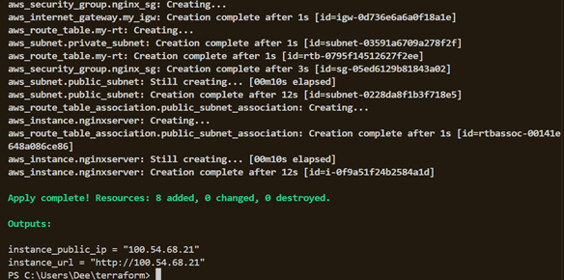

Terraform provisions:
- 1 VPC
- 2 subnets
- 1 Internet Gateway
- 1 Route Table + association
- 1 EC2 instance
- 1 Security Group
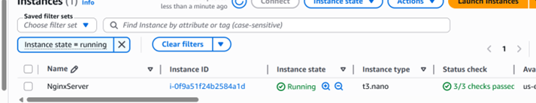

5. Testing the Deployment
Once Terraform completes, access the NGINX server:
http://100.54.68.21
You should see the default NGINX welcome page, confirming:
- EC2 is reachable
- Security group rules are correct
- NGINX installed successfully
- Public subnet routing works

6. Skills Demonstrated

Infrastructure as Code
- Modular Terraform design
- AWS provider configuration
- Reusable, parameterized resources

Cloud Networking
- VPC CIDR planning
- Public/private subnet design
- Internet routing
- Security group hardening

Linux & Web Server Configuration
- Automated NGINX installation
- Systemd service management
- Reverse proxy readiness

7. Future Enhancements
- Application Load Balancer
- Route 53 DNS
- ACM SSL Certificate
- Auto Scaling Group
- CloudWatch monitoring

8. Final Portfolio Summary
EC2 Reverse Proxy NGINX Deployment with Terraform Designed and deployed a fully automated AWS environment using Terraform, including a custom VPC, public/private subnets, routing, security groups, and an EC2 instance running NGINX as a reverse proxy. Implemented modular Terraform configuration, automated server provisioning via user data, and enforced least-privilege network security.

